# **SQL -PORTFOLIO DOCUMENT**

Q1. Show first name of patients that start with the letter 'C'

## Query:

## SELECT first_name FROM patients

## WHERE first_name LIKE 'C%'

## Output:

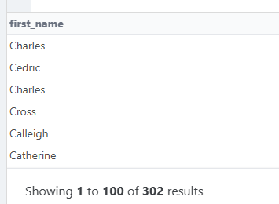

Q2. Show first name,last name of patients only with the gender ‘M’.

## Query:

SELECT first_name, last_name, gender FROM patients

WHERE gender is 'M'

Output:

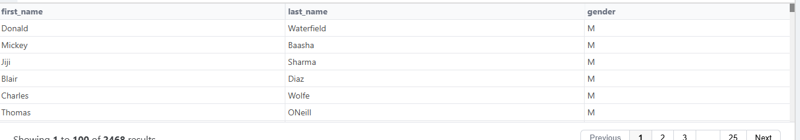

Q4. Show first name and last name of patients who does not have allergies. (null)

## Query:

SELECT first_name, last_name FROM patients

WHERE allergies IS NULL

Output:

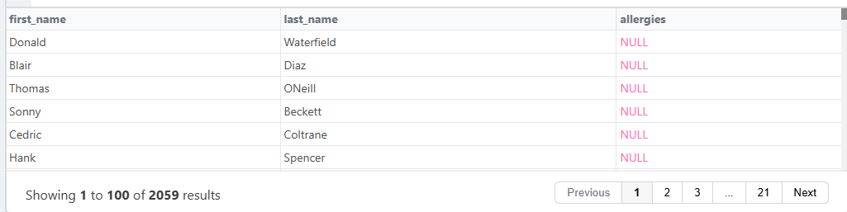

Q5. Show first name and last name of patients that weight within the range of 100 to 120 (inclusive)

## Query:

SELECT first_name, last_name, gender FROM patients

WHERE weight BETWEEN 100 AND 120

Output:

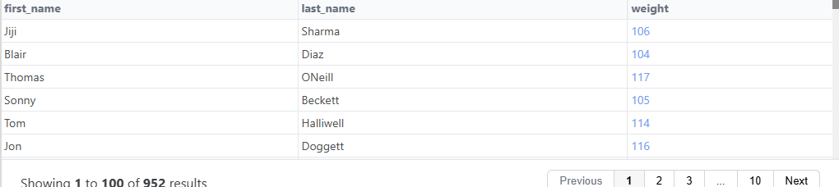

Q6. Update the patients table for the allergies column. If the patient's allergies is null then replace it with 'NKA'

## Query:

SELECT * FROM patients

UPDATE ‘NULL’ =’NKA’

WHERE allergies IS NULL

Output:



Q7. Show first name and last name concatenated into one column to show their full name.

## Query:

SELECT concat(first_name," ", last_name) AS full_name FROM patients

Output:

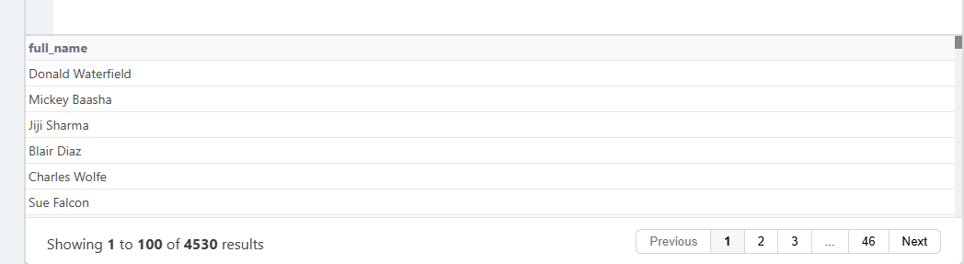

Q8. Show first name, last name, and the **full** province name of each patient.. Example: 'Ontario' instead of 'ON'

## **BEFORE**:

**query**

SELECT * FROM patients

**output**

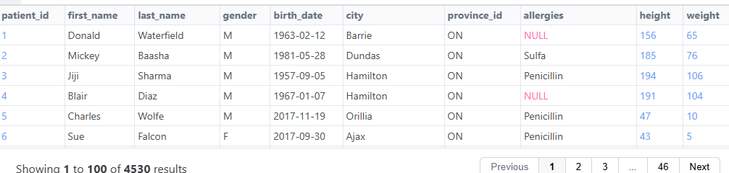

## **AFTER**:

## Query:

SELECT first_name, last_name,province_name FROM patients

JOIN province_names ON province_names.province_id = patients.province_id

Output:

